|  |  |
| --- | --- |
| KSU_logo.jpg | **King Saud University**  **College of Computer and Information Sciences**  **Department of Computer Science** |

**CSC 220: Computer Organization**

**Labwork - 8#**

**Name : Abdulrhman Ali Alsenedi StudentID : 436101804 Section : 32648**

1. **Introduction**

In this Lab Work we are going to design a two Circuits. One its Adder , the other is with Substractor.

1. **Experiments**

**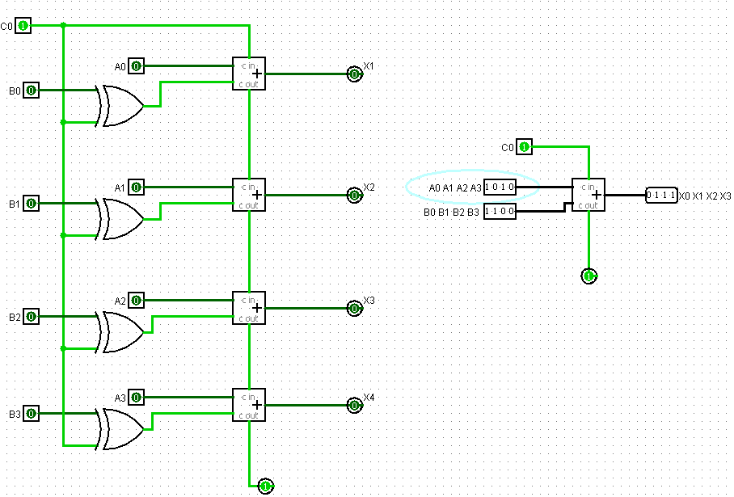**

1. **Discussion**

We cannot add the subs in one Adder, we have to build a N adders to have subs, otherwise we can’t.